*Florida International University*

*School of Computing and Information Sciences*

CIS 4911 - Senior Capstone Project

Software Engineering Focus

Feature Document

User Story #1011

**Team Member:**

Johnatan Jensen

**Product Owner(s)**:

Mohsen Taheri

**Mentor(s)**:

Mohsen Taheri

**Instructor**: Masoud Sadjadi

**User Story Test the Main Features**

* As a Developer I Would Like to test the website’s main features for bugs

**Acceptance Criteria**

* Tested registration
* Tested Login
* Tested Project Proposal
* Tested Student Application
* Tested authorization via access matrix

**Use Case**

1. **Student logs in with Gmail**   
   Participating Actors: Student user  
     
   Entry Condition: Student with @fiu.edu account attempts to log in at vip.fiu.edu/login  
     
   Events Flow:
2. Student clicks gmail button
3. Student is prompted to select an account to log in with
4. User chooses account with @fiu.edu
5. User is redirected to profile page
6. **User creates account**   
   Participating Actors: Any user not a student (they are prompted to use Gmail)  
     
   Entry Condition: Visits vip.fiu.edu/login and goes to “create account” link  
     
   Events Flow:
7. User wishes to create account
8. User clicks “create account”
9. User fills necessary fields
10. User is notified PI approval is pending
11. **Student attempts to apply for Project**   
    Participating Actors: Student user  
      
    Entry Condition: Student user is logged in and attempts to apply for a project  
      
    Events Flow:
    1. Student navigates to project application page
    2. Student knows which project they wish to apply for
    3. Student chooses their project
    4. Student fills the rest of the fields
    5. Student submits the form
    6. Student is notified of a successful submission and Faculty will review it
12. **Faculty attempts to Propose Project**   
    Participating Actors: Faculty user  
      
    Entry Condition: While logged in a faculty user attempts to propose a project  
      
    Events Flow:
    1. Faculty navigates to the project proposal page
    2. Faculty fills the fields in the form
    3. Faculty submits the form
    4. Faculty is notified of successful submission and PI will review it
13. **PI can approve user sign ups**   
    Participating Actors: PI user and any other user type attempting to register  
      
    Entry Condition: A user has registered and is awaiting PI approval. PI receives an email   
      
    Events Flow:
    1. PI receives an email that a user is wishing to create an account
    2. PI clicks on the link in the email
    3. PI reviews the user’s information shown on the form
    4. PI accepts or denies the user
    5. PI is notified their action went through

**Use Case Diagram**

N/A Since this is doing quality assurance on a previously developed feature. See the original feature document made by the former developers of the feature.

**Sequence Diagram**

N/A Since this is doing quality assurance on a previously developed feature. See the original feature document made by the former developers of the feature.

**Class Diagram**

N/A Since this is doing quality assurance on a previously developed feature. See the original feature document made by the former developers of the feature.

**Unit & Integration Tests**

* **Test Case 1**
  + **Purpose:** Main features follow access matrix guidelines
  + **Precondition:** All main features securities are done
  + **Expected Result:** Only appropriate users can access their respective pages
  + **Actual Result:** As expected
  + **Status: PASSED**
* **Test Case 2**
  + **Purpose:** Registration testing for gmail
  + **Precondition:** Registration is implementedand gmail button is functional
  + **Expected Result:** User chooses @fiu.edu account to create new student account. They are then successful and notified they’re pending account approval
  + **Actual Result:** As expected
  + **Status: PASSED**
* **Test Case 3**
  + **Purpose:** Registration testing through “create account” link
  + **Precondition:** Registration is implemented
  + **Expected Result:** Faculty or other non-student user may successfully create an account and is updated when their account is pending approval
  + **Actual Result:** As expected
  + **Status: PASSED**
* **Test Case 4**
  + **Purpose:** Login testing
  + **Precondition:** User has a current account approved
  + **Expected Result:** They are able to login successfully and are redirected to any page
  + **Actual Result:** Expected
  + **Status: PASSED**
* **Test Case 5**
  + **Purpose:** Student application testing
  + **Precondition:** A student user successfully accessed http://vip.fiu.edu/#/studentConfirmation/
  + **Expected Result:** Student has information fields prefilled. Student can submit project. Student receives notification of submission. PI receives email
  + **Actual Result:** As expected
  + **Status: PASSED**
* **Test Case 6**
  + **Purpose:** Emailing system
  + **Precondition:** Emailing scripts are running on proper pages
  + **Expected Result:** On form submissions on registration, student application and project proposal a faculty or PI (depending on constraints) receives an email to approve or deny the requests
  + **Actual Result:** As expected
  + **Status: PASSED**
* **Test Case 7**
  + **Purpose:** Faculty can propose a project
  + **Precondition:** Faculty has successfully accessed the form and filled necessary fields
  + **Expected Result:** Faculty submits project and receives a notification that PI is reviewing it. PI’s receives an email.
  + **Actual Result:** As expected
  + **Status: PASSED**

**Visual User Guide**

**Main features and where to access them**

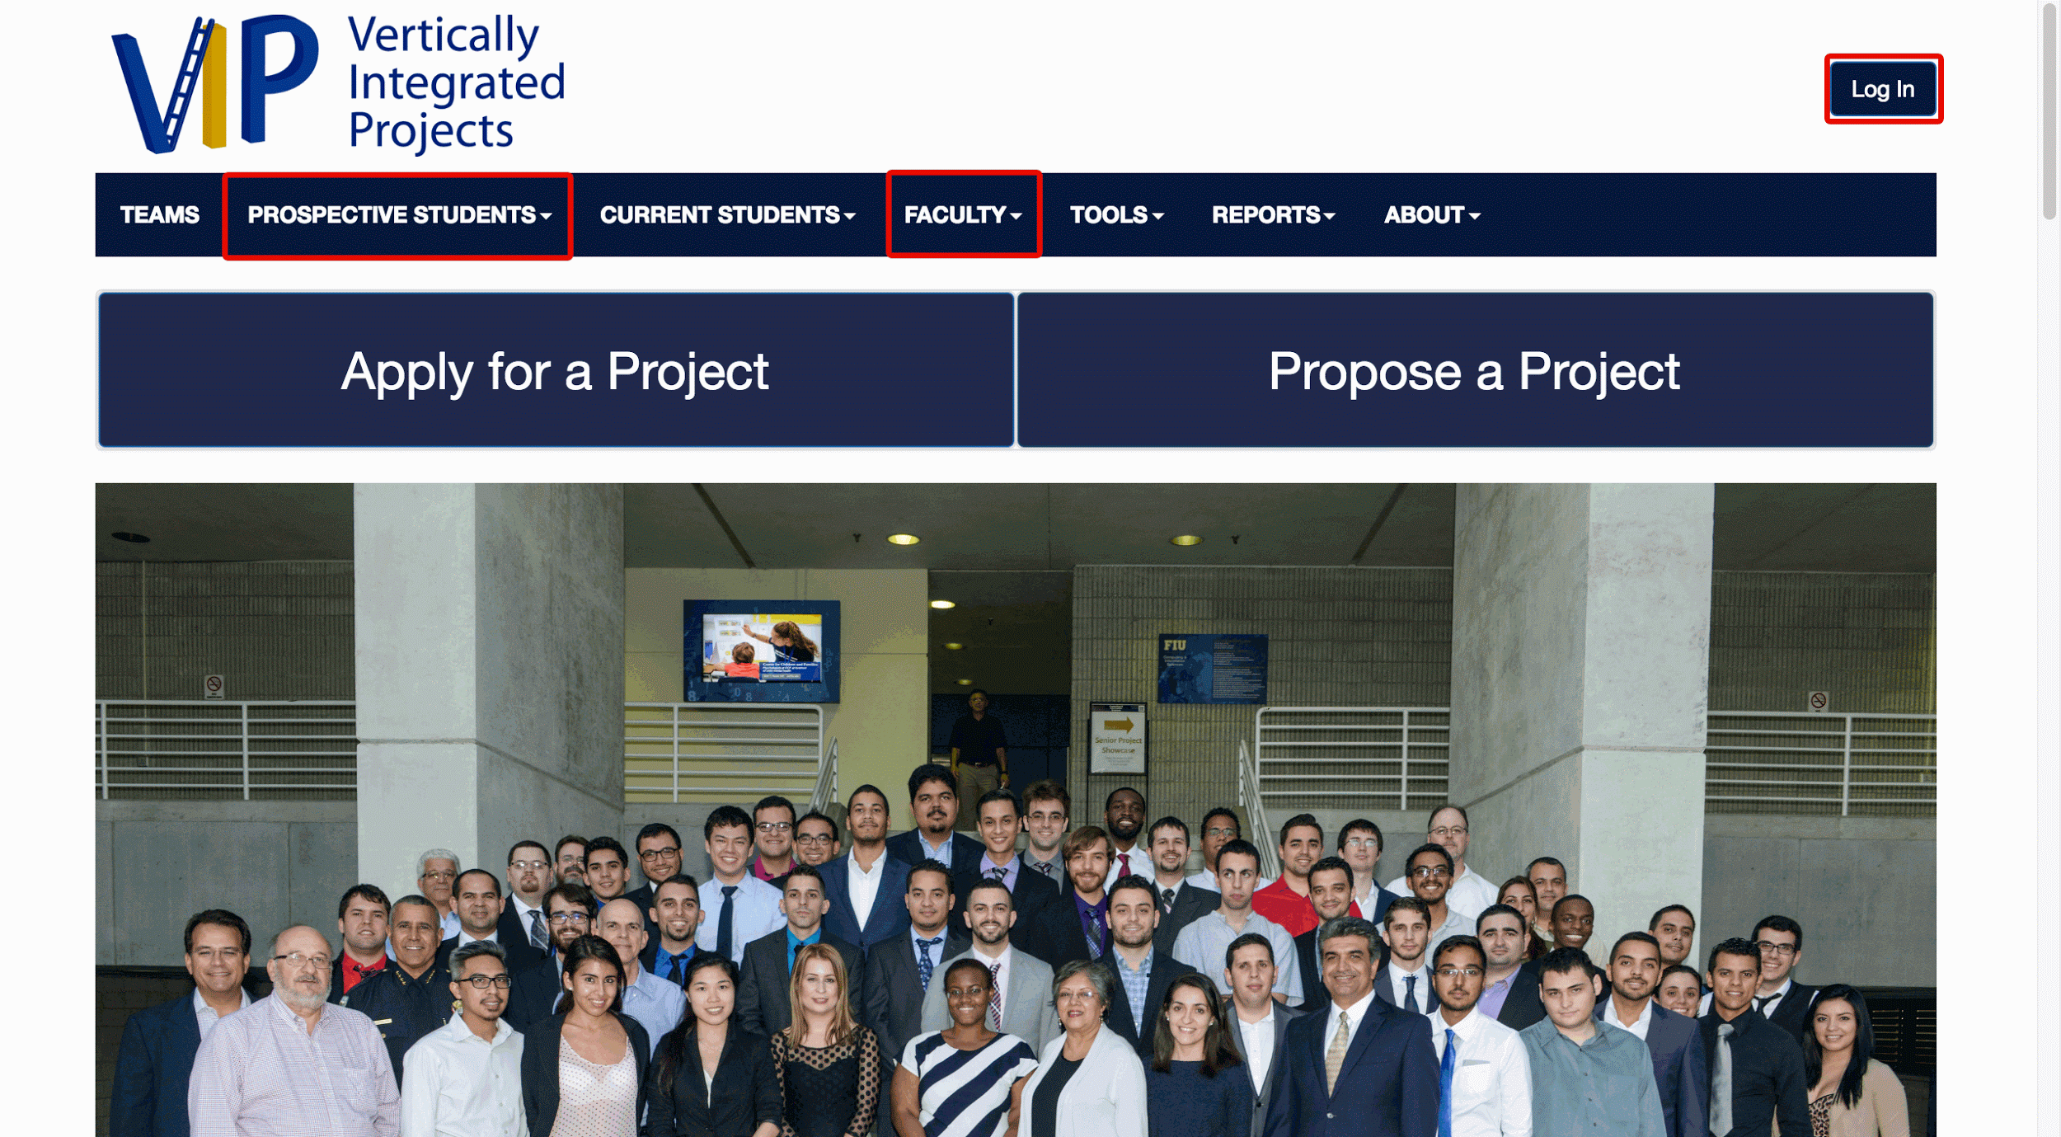

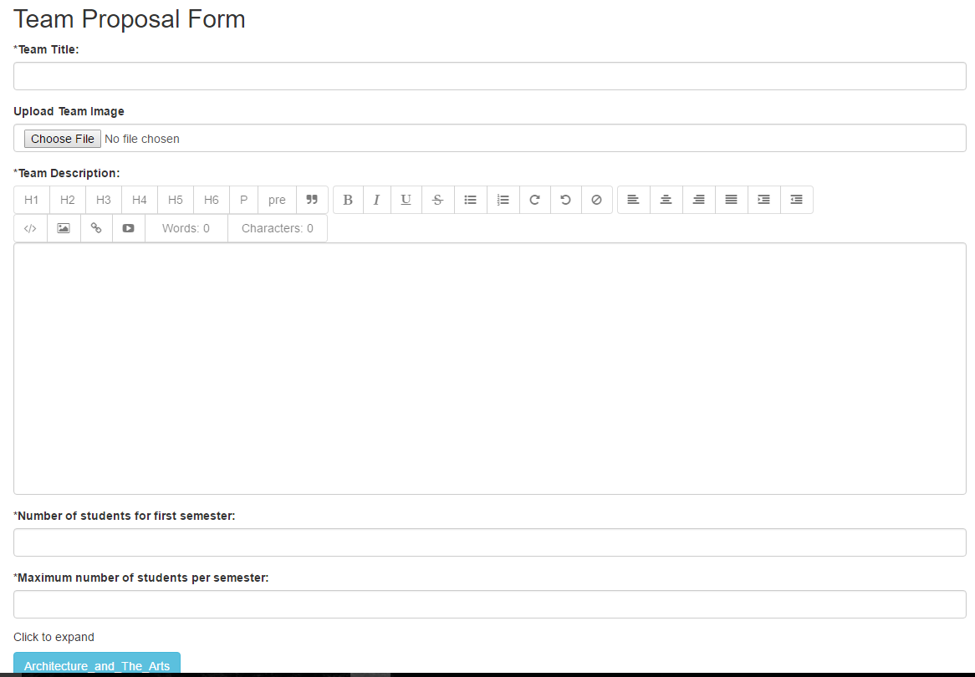

**(Above and below) Main feature forms tested. Pre-filled info is shown.**

